**CICD ASSGINMENT-2**

Pushing a Maven project build to the Nexus repository

1. Create a new maven project using Eclipse IDE

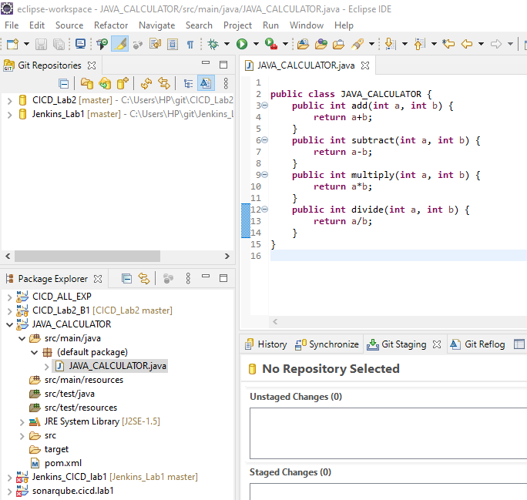

1. After writing the code, create a repository on GitHub to store the project source code

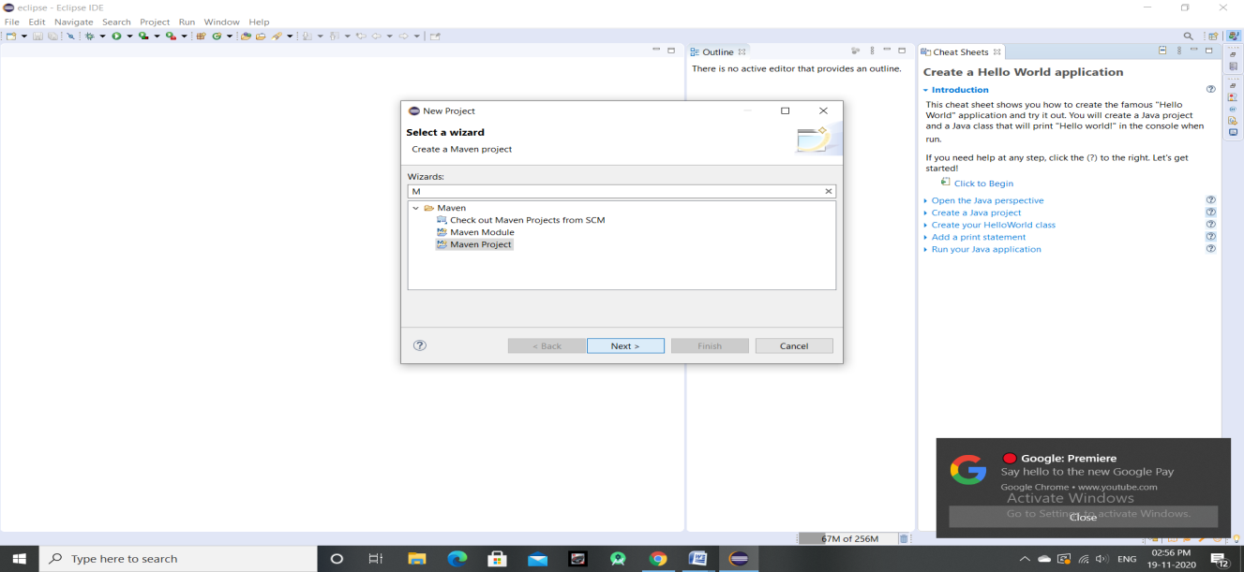

1. Now startyour nexus server by using the following command: nexus.exe /run
2. Create a new Maven hosted Nexus repository

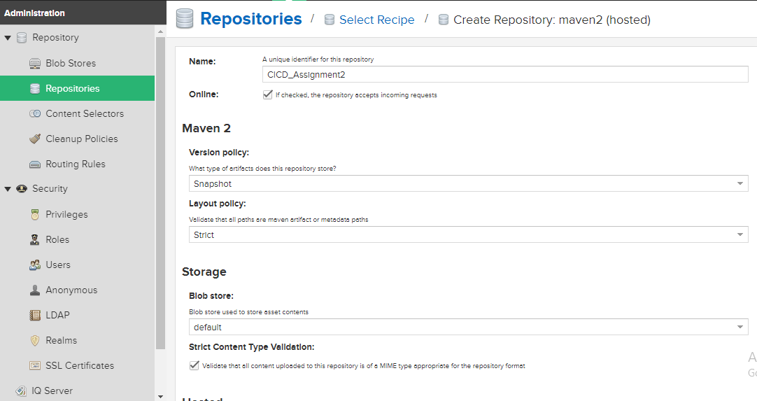

1. Add the distributionManagement tag in the pom.xml file of the project and provide the name, id and url of the Nexus repository

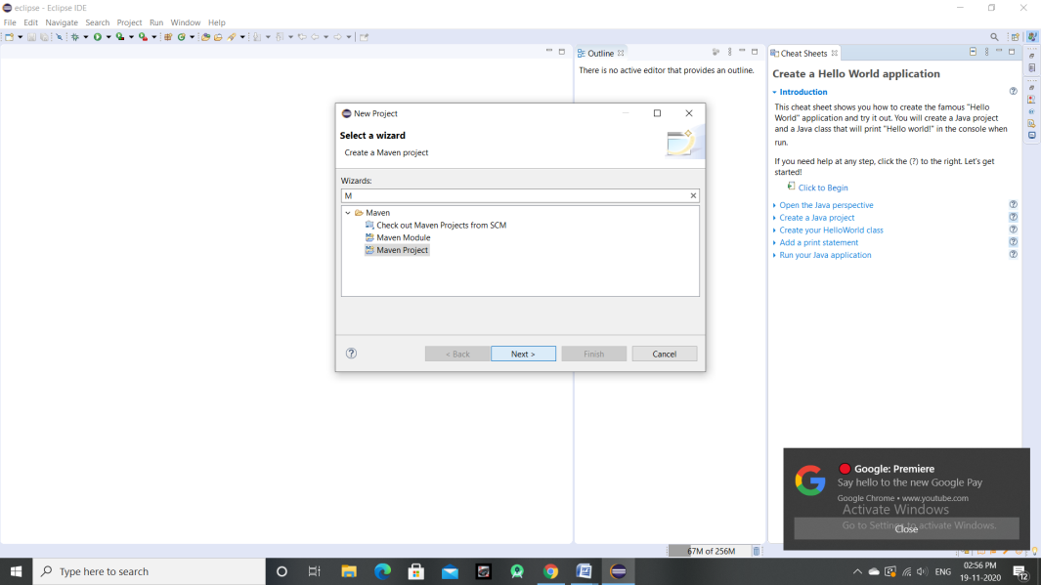

1. Clone the GitHub repository in the Eclipse IDE
2. Link the project with the cloned GitHub repository
3. Commit and push the project to GitHub repository

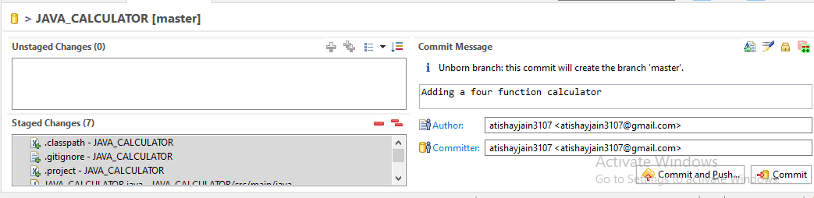

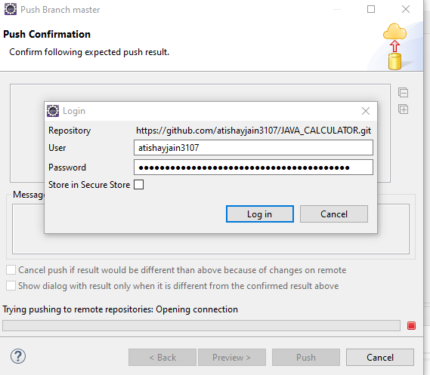

1. Create a Jenkinsfile in the GitHub repository with a deploy stage

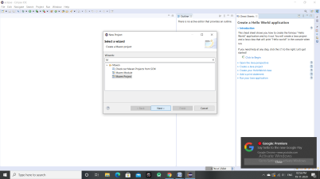

1. Create a new pipeline project in Jenkins and link that project to the above made GitHubrepository. Provide the path to the Jenkinsfile as well

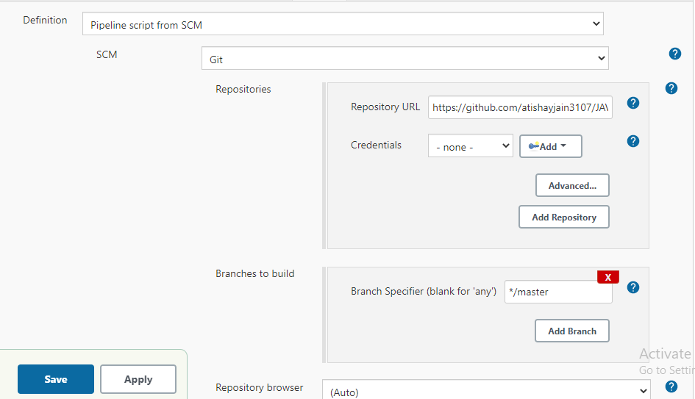

1. Now build the pipeline

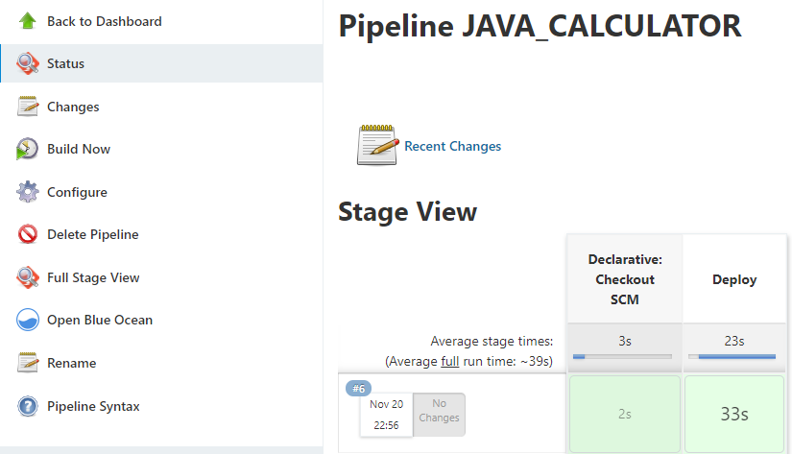

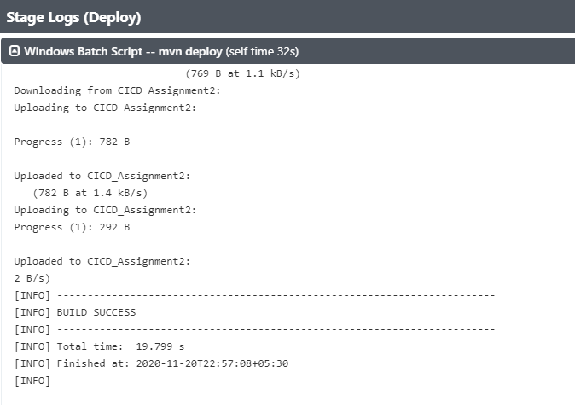

1. After successful build, the artifact is pushed to Nexus repository

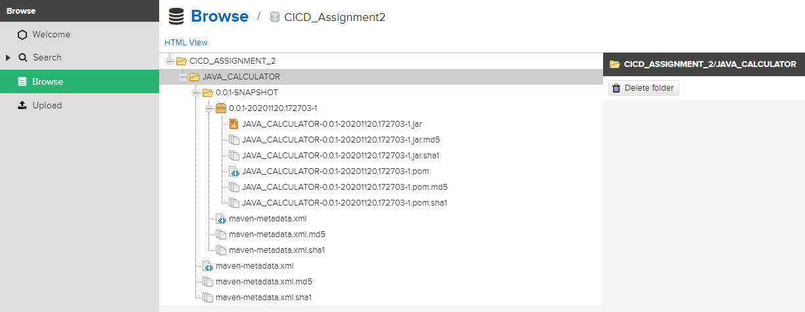

Submitted By:

Atishay Jain

500067694

R171218030

CSE, DEVOPS